Govt. High School
Sindhi Jamaat Co-Operative Housing Society, Karachi
Mid Term Examination 2024-25
Paper: Math | Class: Three | Total Marks: 50
Name: ___________________ |  | Date:

SECTION A
Q1 multiple choice question. (10)
- What is 45+32?
- 67
- 77
- 57
- What is 65-23?
- 32
- 42
- 52
- What is 6×3?
- 18
- 9
- 15
- What is 36÷6?
- 5
- 7
- 6
- How many minutes are there in an hour?
- 30
- 45
- 60

- What is the roman numeral for 10?
- V
- X
- L
- Which of these is an even number?
- 36
- 15
- 23
- What is the next odd number after 31?
- 33
- 32
- 35
- What is the place value of 7 in 572?
- Ones
- Tens
- Hundreds
- If the clock shows 3:30, what is the time in words?
- Half past three
- Quarter to three
- Three O’ clock
Q2 Write true for true statement and false for false statement. (5)
- 23 is an even number. _______
- 52 is an odd number. ________
- The roman numeral for 20 is xx. _______
- There are 60 minutes in an hour. _______
- The place value of 5 in 572 is tens. ______
Q3 Fill in the blanks. (5)
- 1 day = _________ hours
- 1 week = _________days
- 1 month = _________or ___________days
- 1 year = __________months
- 1 minute = ________second.
Section B
Q4 write time for analog and digital clocks. (5)
Analog clock

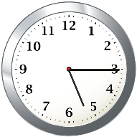
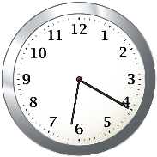

_____________ _______________

Digital clock
- 06:15
__________
- 04:45
_________
- 09:30
________
Q5 Solve the following. (6)
431 582 2746
+24 +137 1012
_______ ________ +1421
_______ ________ _________
_________

Q6 Solve the following. (6)
88 639 356
-47 -38 -178
______ ______ ______
______ ______ ______
Q7 Solve the following. (3)
13 21 15
×2 ×7 ×3
_______ _______ _________
_______ _______ _________
Q8 Solve the following. (3)
3∫15 2∫50 10∫90

Q9 Write down the following in roman numbers. (4)
- 5 _________
- 7 _________
- 11 ________
- 9 _________
Q10 Write the table of 6 or 7. (3)

